**Mobile Application Development**

**Milestone 2 – Aidan Lietz**

**GitHub Project URL:** [**https://github.com/Ados43/MobAppDev-ToDo**](https://github.com/Ados43/MobAppDev-ToDo)

**App Screenshot Homepage (Web): App Screenshot Add New Todo (Web):**

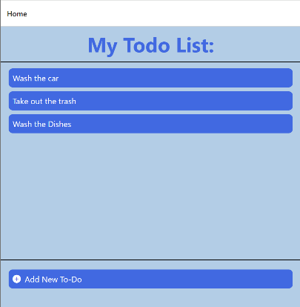

**App Screenshot Homepage App Screenshot Add New Todo   
(IOS Emulator): (IOS Emulator):**

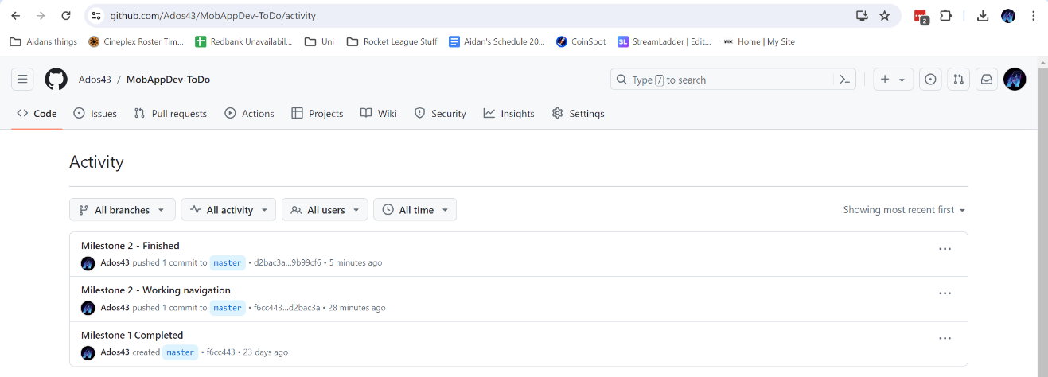GitHub Commit history screenshot: